AYDIN ADNAN MENDERES UNIVERSITY
ENGINEERING FACULTY
…… ENGINEERING DEPARTMENT
THESIS TITLE
(Font size:16 pt, Bold, In all capitals)

Student’s Name SURNAME
(In alphabetical order by surname if more than one)
(Font Size:12 pt, Bold, Surname in all capitals)d
Supervisor:
Thesis Supervisor’s Title Name SURNAME
(Font Size:12, Bold, Surname in all capitals)

AYDIN ADNAN MENDERES UNIVERSITY
ENGINEERING FACULTY
…… ENGINEERING DEPARTMENT
THESIS TITLE
(Font size:16 pt, Bold, In all capitals)

Student’s Name SURNAME
(In alphabetical order by surname if more than one)
(Font Size:12 pt, Bold, Surname in all capitals)
Supervisor:
Title Name SURNAME
(Font Size:12 pt, Bold, Surname in all capitals)

ABSTRACT
THESIS TITLE
(Font size: 12 pt, Bold, In all Capitals)
Student’s Name SURNAME
B.Sc. Thesis, …… Engineering Department
Supervisor: Title Name SURNAME
{Year}, {Number of Pages} pages
The abstract should cover a clear statement of the object or aim of the study including brief statements of the problem, procedures or methods used, results and conclusions. Abstracts should not contain references, headings, tables, figures, formulae or footnotes. Abstract should not exceed one page. Maximum five keywords must be written at the end of the abstract separated by commas.
Keywords: Maximum five keywords separated by commas.

ÖZET
TEZ BAŞLIĞI
(Font size: 12 pt, Bold, In all Capitals)
İsim SOYİSİM
Lisans Bitirme Tezi, …… Mühendisliği Bölümü
Tez Danışmanı: Unvan İsim SOYİSİM
{Yıl}, {Sayfa sayısı} sayfa
Özet is the Turkish translation of the abstract. The Turkish Abstract (“Özet”) must be written in the same format as English Abstract. Maximum five keywords in Turkish must be written at the end of the abstract separated by commas.
Anahtar Kelimeler: Maximum five keywords separated by commas in Turkish.

ACKNOWLEDGEMENT
In this section, the authors can acknowledge persons and establishments that contribute to this project directly or indirectly. The title, name-surname, duty on the thesis and contribution to the study of the contributor should be mentioned shortly.
If the thesis completed within the scope of the project, project name, number and the name of the relevant organization should be mentioned.

TABLE OF CONTENTS
ABSTRACT i
ÖZET iii
ACKNOWLEDGEMENT v
LIST OF TABLES ix
LIST OF FIGURES xi
LIST OF ABBREVIATIONS xiii
LIST OF SYMBOLS xv
1. INTRODUCTION 1
1.1. Outer cover 1
1.2. Inner cover 2
1.3. Dedication page 2
1.4. Abstract 2
1.5. Özet 2
1.6. Acknowledgement 3
1.7. Table of contents 3
1.8. List of Tables 3
1.9. List of Figures 3
1.10. Abbreviations 3
1.11. List of Symbols 3
1.12. Main Body of the Thesis 3
1.12.1. Introduction 4
1.12.2. Materials and Methods 4
1.12.3. Results and Discussion 4
1.12.4. Conclusions 4
2. FORMAT AND APPEARANCE 5
2.1. Paper 5
TABLE OF CONTENTS (CONTINUED)
2.2. Margins 5
2.3. Font 5
2.4. Spacing 5
2.5. Corrections 6
2.6. Centering 6
2.7. Pagination 6
2.8. Titles 6
2.9. Illustrative material 7
2.10. Formulas and Equations 9
2.11. Binding 9
3. CITATION STYLE AND REFERENCING 10
3.1. Examples 10
3.2. Reference management software 11
REFERENCES 12
APPENDICES

LIST OF TABLES
Table 1. Sample table. 7

LIST OF FIGURES
Figure 1. Sample figure. 8
Figure 2. Examples of binding types: (a) Perfect Bound and (b) Coil Bound. 9

LIST OF ABBREVIATIONS
APA American Psychological Association
ISO International Organization for Standardization

LIST OF SYMBOLS
E Energy
m Mass
C Speed of light

1. INTRODUCTION
The aim of this manual is to give detailed guidelines for composing and writing a thesis. This section explains the instructions for the different parts of the thesis which are outer cover, inner cover, dedication page, foreword, table of contents, abbreviations, symbols, list of tables and figures, introduction, materials and methods, results and discussion and conclusions.
Typically, the presentation order of the thesis chapters is listed as following:
- Outer cover
- Inner cover
- Dedication page (optional)
- Abstract
- Özet
- Acknowledgement
- Table of contents
- List of Tables
- List of Figures
- Abbreviations
- Symbols
- Main body of the text
- References
- Appendices

1.1. Outer cover
Outer cover page gives expressions for name of university, name of faculty, name of department, title of thesis in accordance with the thesis template. See first page of this manual for sample outer cover.
• Thesis title should not contain any chemical or mathematical formulas, symbols, or other non-standard abbreviations.
• The title should be clearly defined in the context of thesis topic.
• Department names used in thesis must be officially approved names by the Engineering Faculty (e.g. Food Engineering Department).

1.2. Inner cover
Inner cover page consists of name of university, name of faculty, name of department, title of thesis, thesis advisor, date of submission in accordance with the thesis template.
• Thesis title should not contain any chemical or mathematical formulas, symbols, or other non-standard abbreviations.
• Department names used in thesis must be officially approved names by the Engineering Faculty (e.g. Food Engineering Department).
• Thesis supervisor must be written as title, name and surname of advisor.
• Date of Submission must be written as month and year (e.g. Date of Submission: June 2017).

1.3. Dedication page
If dedication exists, it must be brief and centered vertically on the page. A title on the dedication page is not required. See Appendix B for a sample page.

1.4. Abstract
The abstract should cover a clear statement of the objective or aim of the study including brief statements of the problem, procedures or methods used, results and conclusions. Abstracts should not contain references, headings, tables, figures, formulae or footnotes. Abstract should not exceed one page. Maximum five keywords must be written at the end of the abstract separated by commas.

1.5. Özet
Özet is the Turkish translation of the abstract. The Turkish Abstract (“Özet”) must be written in the same format as English Abstract. Maximum five keywords in Turkish must be written at the end of the abstract separated by commas.

1.6. Acknowledgement
The acknowledgement is optional and can be used to acknowledge those who have contributed to your work as well as to explain your motivation. The forewords can also include research stages, present partners, and funding. Typically, the foreword is from a half to one page in length.

1.7. Table of contents
Table of contents presents a quick overview of the structure of the thesis. The table of contents lists the chapters with their headings and subheadings and their respective page numbers. All headings in the table must match the headings in the text.

1.8. List of Tables
Tables given in the main body must be listed in “List of Tables” page with table number, table caption and page number they first appear.

1.9. List of Figures
Figures given in the main body must be listed in “List of Figures” page with figure number, figure caption and page number they first appear.

1.10. Abbreviations
A list of abbreviations contains all the abbreviations used in the thesis and their corresponding definitions. All abbreviations must be explained when they first appear in the text.

1.11. List of Symbols
All symbols used in the thesis have to be listed on this page. Validity of all symbols should be checked from reliable sources. Concerning measurement units, the internationally approved SI system of symbols should be used.

1.12. Main Body of the Thesis
Content of the main body depends on the type of thesis subject (laboratory, case study, review etc.) and is typically comprised of introduction, materials and methods (if necessary), results and discussion, conclusion and other relevant sections.

1.12.1. Introduction
The purpose, scope and significance of the thesis must be discussed within the introduction part. The hypothesis that the study built on must be explicitly defined. The contribution of the results to industry and to literature must be represented. Similar studies about the research topic of thesis must be researched and cited. There may be different subheadings in the introduction part. Special attention must be paid to check grammar mistakes.

1.12.2. Materials and Methods
The materials used in the thesis must be explained. The analysis techniques and methods must be cited and clarified in details. Alternative methodologies or plans can also be defined if any problems occur during performing the study.

1.12.3. Results and Discussion
The scientific outcomes of the thesis must be presented within the results and discussion part. All figures and tables belonging to the topic must be placed where appropriate. The results must be compared with similar studies in literature. If there are discrepancies, possible causes must be explained.

1.12.4. Conclusions
The conclusions of the thesis should be written in this part. The possible contributions to economy and scientific knowledge which can be attained as results of the thesis have to be discussed. Guidelines may also be added for future works.

2. FORMAT AND APPEARANCE
Every thesis which will carry the name of Aydın Adnan Menderes University, Engineering Faculty must meet the same high standards of presentation in terms of all pertinent physical properties, including format as well as paper and print quality. The following guidelines are related to the format and appearance of the thesis that you are going to prepare.

2.1. Paper
All copies of the thesis must be on good quality white bond paper, of at least 75 g, measuring 210 by 297 mm (ISO A4) to insure durability, permanency, and opacity. All copies of the thesis must be two-sided.

2.2. Margins
The binding side must be at least 4 cm wide to allow for binding; other three margins must be at least 2.5 cm wide. Narrower margins are not acceptable. Headings, page numbers, text, tables, illustrations, etc., must all be contained completely within the area bounded by the margins.

2.3. Font
The font size should be 12-point. Only Times New Roman font is acceptable. Do not use script or ornamental fonts. The font type and font size must be consistent throughout the thesis. Bold face letters, symbols, and italics may be used for special emphasis and foreign words.
In the body of the thesis, point sizes different from the rest of the text may be used to set off footnotes, endnotes, examples, quotations, tables, and charts, as long as their use is consistent and they are easily readable.

2.4. Spacing
The general text of the manuscript must use 1.5 spacing. However, tables, long quotations, footnotes, endnotes, bibliographies, and captions may be single-spaced. Justified alignment must be used throughout all paragraphs.
Space between paragraphs must be 6 points.

2.5. Corrections
No ink corrections, strikeovers, correction fluid, correction tape, paste-ups, insertions between lines, or letterset are permitted on the final bound copies. If you must make corrections, make them on the original manuscript (but not by ink corrections or strikeovers which are never allowed) before it is copied for reproduction.

2.6. Centering
All materials must be centered between the text margins rather than between the paper edges. After the manuscript is bound, the centered material will appear to be centered on the page. In paragraphs, two types of formatting can be used. If spacing between paragraphs is used, then there is no need for indentation. If indentation is used, then no spacing must be used between paragraphs.

2.7. Pagination
All page numbers must appear in the footer of the page centered. Page numbers must be at least 1.25 cm above the page border. All page numbers must be 12-pt Times New Roman.
The following pagination rules must be used:
- For the preliminary pages, use small Roman numerals (i, ii, iii, iv, see ‘Table of Contents’ page) must be used. The back side of the title page should be blank.
- Use Arabic numerals beginning with "1" on the first page of the text and continue throughout the rest of the thesis, including bibliography, appendices, and vita. All pages must be numbered consecutively, including pages containing tables and figures.

2.8. Titles
All new chapters must start at new page. Titles must not contain any chemical or mathematical formulas, symbols, or other non-standard abbreviations or character if it is not possible to print them on page. Thus, such information must be substituted for words. Formats regarding to first-level title and subtitles are as listed below:

- 1. FIRST-LEVEL TITLE (12-pt, bold, in all capitals)
- 1.1. Second-level Title (12-pt, bold, capitalized)
- 1.1.1. Third and further level titles (12-pt, only first letter of title in capital)
One-character space is required after title enumerations.

2.9. Illustrative material
Illustrations include drawings, charts, figures, tables, and diagrams. These may be inserted wherever the author(s) feel appropriate, but as a general rule, should appear as near as possible to the part of the text which refers to them.
Tables and figures must be placed where they are initially cited. The numbering for each table and figure must be consecutive in the text. Each illustrative material must have a number and a title, and must be mentioned in the text. Figures must be cited as “Figure 1, Figure 2, etc.” and tables must be cited as “Table 1, Table 2, etc.”.
It must be also noted that all of items including charts, photographs, lists and illustrations should be considered as a table or figure.
Table numbers and captions are placed 6 pts above the top line of the illustration aligned left; figure numbers and captions are placed 6 pts below the last line or bottom of the illustration and centered. Sample templates regarding a table and a figure are presented in Table 1 and Figure 1, respectively.
Table 1. Sample table.
 | Column 1 | Column 2 | Column 3 | Column 4
Row 1 | 1,1 | 1,2 | 1,3 | 1,4
Row 2 | 2,1 | 2,2 | 2,3 | 2,4
Illustrations may exceed one page. In such cases, all subsequent pages of the illustration must include at least the illustration number and the notation that is continued, e.g., "Table 1 (continued)".
Algorithms not exceeding one page should be presented as figures, otherwise as appendix.
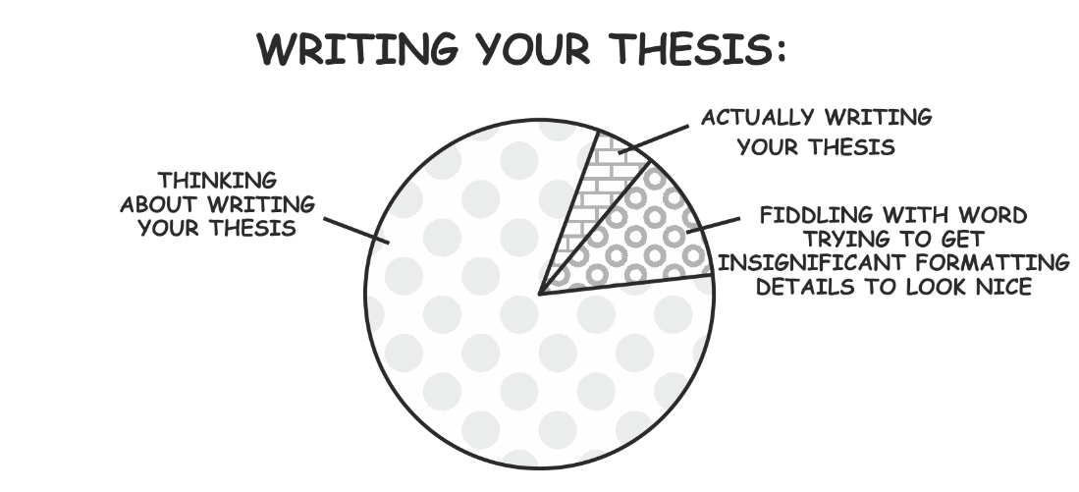
Figure 1. Sample figure.
Illustrations of one-half page or less in length may appear on the same page with the text, separated from the text above and below by three space. Illustrations that are too large to be placed sideways between the left- and right-hand margins should be rotated counterclockwise 90 degrees so that the top of the illustration runs parallel to the left-hand margin of the page. In such a case, the whole page must be reserved only for that illustration. The caption or legend for such an illustration must also be rotated. When illustrations are presented in this manner, the usual margin requirements remain in effect, and page numbers should appear in their normal place.
Interrelated multiple figures can be presented as a compound figure instead of separate figures. Compound figures share a common caption. Each figure must be clearly identified by lower-case letter (a, b, c, etc.), and referenced by that letter in text, (e.g. Figure 1a). Sample compound figure can be seen in Figure 2.
All headings and captions must be prepared either in the same font and point size used for the text, or in the same font and point size as every other heading and caption. Minimum 8-pt font size is acceptable, especially for tables, axis scales, axis titles, legends, and labels in charts and diagrams.
Color may be used in figures and photographs as long as duplicate copies are all produced by color photocopy. Photographic illustrations must be originals or well-made photographic copies of the originals.
If an audio visual material (e.g., videotape, cassette, etc.) is needed to accompany and supplement the text, it should be adequately described within the continuity of the text.
Stored information in the form of optical disc (e.g. CD, DVD) will be submitted with all copies.

2.10. Formulas and Equations
Mathematical and chemical formulas, equations and expressions can be prepared by using an appropriate equation editor. Each equation must be numbered in parentheses and this must be given next to the right margin. Citation to an equation is identified by corresponding equation number. Albert Einstein’s special relativity equation is given as an example in Eq. (1).
$E=mc^{2}$ (1)

2.11. Binding
All thesis reports are to be perfect bound. Perfect binding is illustrated in Figure 2a.
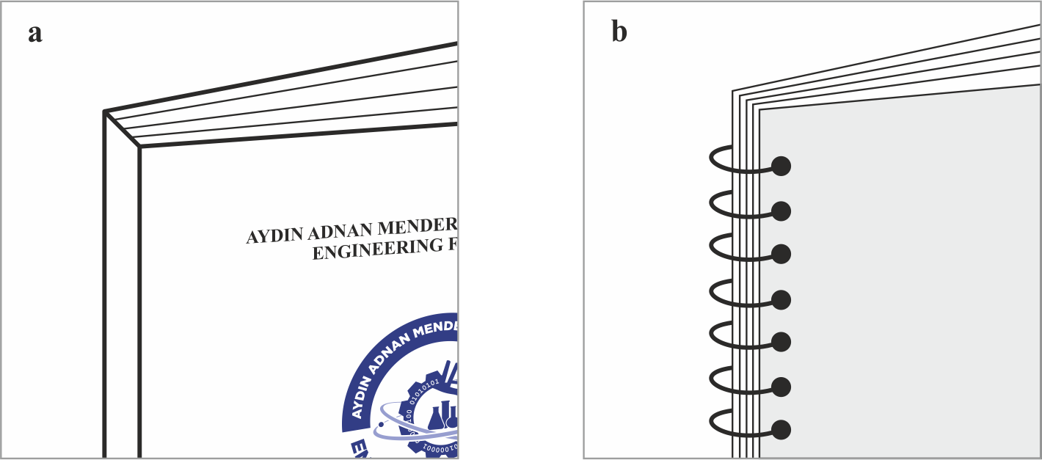
Figure 2. Examples of binding types: (a) Perfect Bound and (b) Coil Bound.

3. CITATION STYLE AND REFERENCING
All publications cited in the text should be presented in a list of references. Citations in the text should follow the referencing style used by the American Psychological Association (APA). In the text refer to the author's name (without initials) and year of publication (e.g. "Utrera, Parra and Estevez (2014) studied the effects..." or "...similar results were reported by other groups (Bhat & Madyastha, 2000; Madhava et al., 2000)"). For 2-6 authors all authors are to be listed at first citation. At subsequent citations use first author et al.. When there are more than 6 authors, first author et al. should be used throughout the text.
The list of references should be arranged first alphabetically and then further sorted chronologically if necessary. More than one reference from the same author(s) in the same year must be identified by the letters 'a', 'b', 'c', etc., placed after the year of publication.

3.1. Examples
Following examples are given for different resource types for APA style citation.
- Reference to a journal publication: Utrera, M., Parra, V., & Estévez, M. (2014). Protein oxidation during frozen storage and subsequent processing of different beef muscles. Meat Science, 96(2), 812-820.
- Reference to a book: Callister Jr, W. D., & Rethwisch, D. G. (2012). Fundamentals of materials science and engineering: an integrated approach. John Wiley & Sons.
- Reference to a chapter in an edited book: Mettam, G. R., & Adams, L. B. (2009). How to prepare an electronic version of your article? In B. S. Jones, & R. Z. Smith (Eds.), Introduction to the electronic age (pp. 281–304). New York: E-Publishing Inc.
- Reference to a website: Cancer Research UK. Cancer statistics reports for the UK. (2003). http://www.cancerresearchuk.org/aboutcancer/statistics/ Accessed 13 March 2003.
- Reference to a dataset: [dataset] Oguro, M., Imahiro, S., Saito, S., Nakashizuka, T. (2015). Mortality data for Japanese oak wilt disease and surrounding forest compositions. Mendeley Data, v1. https://doi.org/10.17632/ xwj98nb39r.1.
- Reference to a conference paper or poster presentation: Engle, E.K., Cash, T.F., & Jarry, J.L. (2009, November). The Body Image Behaviours Inventory-3: Development and validation of the Body Image Compulsive Actions and Body Image Avoidance Scales. Poster session presentation at the meeting of the Association for Behavioural and Cognitive Therapies, New York, NY.

3.2. Reference management software
When preparing your thesis, you can use reference management software products such as EndNote, Mendeley, RefWorks or Zotero. Using the word processor plug-ins from these products, you only need to select the appropriate template (APA) when preparing your thesis, after which citations and bibliographies will be automatically formatted in APA style.

REFERENCES
Callister Jr, W. D., & Rethwisch, D. G. (2012). Fundamentals of materials science and engineering: an integrated approach. John Wiley & Sons.
Mettam, G. R., & Adams, L. B. (2009). How to prepare an electronic version of your article? In B. S. Jones, & R. Z. Smith (Eds.), Introduction to the electronic age (pp. 281–304). New York: E-Publishing Inc.
Utrera, M., Parra, V., & Estévez, M. (2014). Protein oxidation during frozen storage and subsequent processing of different beef muscles. Meat Science, 96(2), 812-820.

By the Work-Energy Theorem:
$$W=K×E$$
In this case, we will consider PE = 0 so:
$$W=K×E=E$$
From the definition of work:
$W=F(∆x)$ $E=F(∆x)$
Therefore:
$$E=\int_{0}^{x}{Fdx}$$
From Newton’s original statement of F=m×a:
$F=\frac{dm}{dt}v+m\frac{dv}{dt}$ $F=\frac{d}{dt}(mv)$
This, along with the previous equation yields:
$$E=\int_{0}^{x}{\frac{d}{dt}\left(mv\right)dx}$$
We have dt and dx in the equation. Let’s write it all in terms of dt:
$$v=\frac{∆x}{∆t}=\frac{dx}{dt} dx=vdt$$
When the variable changes from dx to dt, we must also change the bounds of the integral:
$$E=\int_{0}^{x}{\frac{d}{dt}\left(mv\right)dx=\int_{0}^{t}{\frac{d}{dt}\left(mv\right)vdt}}$$
We can eliminate the dt’s so:
$$E=\int_{0}^{t}{\frac{d}{dt}\left(mv\right)vdt=}\int_{0}^{mv}{vd\left(mv\right)}$$
Notice that the dt changed to d(mv) so the bounds also changed for velocities approaching c, the mass increases. The relativistic mass is:
$m=\frac{m_{0}}{\sqrt{1-\frac{v^{2}}{c^{2}}}}$ $E=\int_{0}^{mv}{vd\left(mv\right)= \int_{0}^{mv}{vd\left(\frac{m_{0}v}{\sqrt{1-\frac{v^{2}}{c^{2}}}}\right)}}$

Applying the Quotient Rule:
$$d\left(\frac{v}{\sqrt{1-\frac{v^{2}}{c^{2}}}}\right)=\frac{dv\sqrt{1-\frac{v^{2}}{c^{2}}}-v\left(\frac{1}{2}\right){\left(1-\frac{v^{2}}{c^{2}}\right)}^{-\frac{1}{2}}\left(-\frac{1}{c^{2}}\right)\left(2vdv\right)}{1-\frac{v^{2}}{c^{2}}}$$
Combining these expressions for Energy:
$$E=m_{0}\int_{0}^{v}{vd\left(\frac{v}{\sqrt{1-\frac{v^{2}}{c^{2}}}}\right)}$$
Simplifying:
$$E=m_{0}\int_{0}^{v}{\left[\frac{\left(1-\frac{v^{2}}{c^{2}}\right)v}{{\left(1-\frac{v^{2}}{c^{2}}\right)}^{\frac{3}{2}}}+\frac{\frac{v^{3}}{c^{2}}}{{\left(1-\frac{v^{2}}{c^{2}}\right)}^{\frac{3}{2}}}\right]dv}$$
$$E=m_{0}c^{3}\int_{0}^{v}{\frac{v}{{\left(c^{2}-v^{2}\right)}^{\frac{3}{2}}}dv}$$
$$E=c^{2}\left(\frac{m_{0}}{\sqrt{1-\frac{v^{2}}{c^{2}}}}-m_{0}\right)$$
Relativistic mass:
$$m=\frac{m_{0}}{\sqrt{1-\frac{v^{2}}{c^{2}}}}$$
Substituting relativistic mass yields:
$$E=\left(m-m_{0}\right)c^{2}$$

to my family…

